Information for Exhibitors

- As judging will start at 7:00 pm sharp, please have your entries in by 6:45 pm.
Doors will open at 6:00 pm.

- Exhibitors must complete and attach entry tags to each entry. *Remember that if two entries are tied, the educational benefit of a named specimen will win over the unnamed one.

- Show ribbons are stickers on the entry tags. (1st red , 2nd blue, 3rd silver)

- Scoring: First 6 points, Second 4 points, Third 2 points

- Best in Show – Judges Choice – receives 10 points.

- Best Overall Certificate is awarded to exhibitor with highest aggregate of show points.

- Plant Certificate awarded to the exhibitor with the most points in the horticulture division

- Design Certificate awarded to the exhibitor with the most points in the design division

Note: While it’s nice to exhibit perfect flowers or plant specimens, most of us don’t have these growing in our gardens (at least not on show day). We have the kind of flowers where maybe a bug has eaten off part of a petal, or it was at its peak a few days ago. Please don’t feel your exhibit has to be perfect in order to enter it. The only exception – please no bugs on the plant or flower

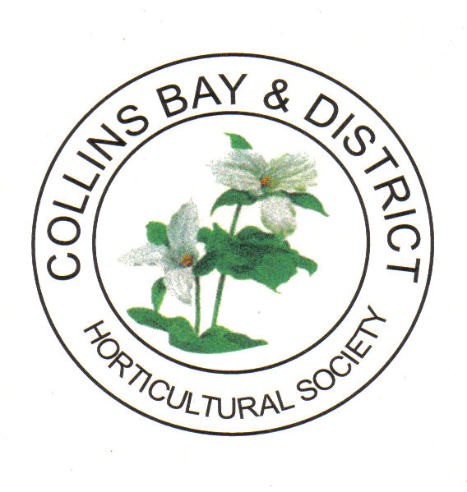
June Flower Show
June 11th, 2023

St. Peters Anglican Church
4333 Bath Road near Coronation Blvd.

Rules for Exhibitors

- Exhibitors must be paid up members of the Collins Bay and District Horticultural Society.

- Normally only one entry per person is allowed for each class, however; for Irises, Peonies, Roses and Fruits or Vegetable, up to three entries are allowed per exhibitor. (Each one must be a different cultivar.)

- Cultural exhibits must have been grown by the exhibitor for a minimum of two months prior to show time.

- Cultural entries are shown with attached foliage unless otherwise stated.

- Decorative arrangements or designs are to be created by the exhibitor.

- Decorative classes are to use at least some fresh plant material. Discrete use of painted or treated material is allowed. However, the use of artificial plant material is not allowed.

- It is the responsibility of the exhibitor to place each entry in the correct class. The Show Committee is also responsible for ensuring that all entries are in proper classes prior to judging. Spacing of entries may be adjusted by the Show Committee.

- An exhibit may not be awarded a prize, even if it is the only entry in its class unless the judge considers it to have sufficient merit.

- The decision of the judges shall be final. Any protest must be in writing and submitted to the Show Chair.

Division 1: Horticultural Classes

Section A - Garden Plants
Class 1 Bearded Iris, 1 stalk
Class 2 Beardless Iris, 1 stalk
Class 3 Miniature Iris, 2 stalks under 25 cm - 10”
Class 4 Peony, 1 bloom single form
Class 5 Peony, 1 bloom, double form
Class 6 Rose, 1 bloom
Class 7 Shrub Rose, 1 spray
Class 8 Pansy/Viola, 3 blooms with foliage attached, any colour
Class 9 Flowering Branch, 1 stem, not to exceed 60 cm - 24”
Class 10 Heuchera, 3 leaves 3 different varieties
Class 11 Heuchera, 3 leaves one variety
Class 12 Hosta, 3 leaves, 3 different varieties
Class 13 Hosta 3 leaves, 1 variety miniature
Class 14 Hosta 3 leaves, 1 variety solid colour
Class 15 Hosta 3 leaves, 1 variety variegated
Class 16 Any other perennial or biennial, 1 stem, named.
Class 17 Any flowering bulb/corm/rhizome, 3 stems named
Class 18 Collection of perennials, 3 varieties, 1 stem each, named
Class 19 Collection of herbs, 3 varieties named
Class 20 Any fruit or vegetable, 3 specimens named
Class 21 One floating bloom with own leaves

Section B - Houseplants
Class 22 African violet, single crown
Class 23 Foliage plant - Any houseplant grown primarily for foliage
Class 24 Flowering plant Any houseplant grown primarily for blooms
Class 25 Cactus or Succulent, under 20 cm - 8”
Class 26 Cactus or Succulent, over 20 cm - 8”
Class 27 Container garden, 3 specimens or more
Class 28 Begonia
Class 29 Orchid, in bloom, named if possible

Division 2 - Decorative Classes
Floral Arrangement
Class 30 Water Feature
Class 31 Tall design (viewed from the front)
Class 32 Centerpiece design (all around view)
Class 33 Small Design – an arrangement in a teacup (25 cm -10” max)
Class 34 Miniature design - (not to exceed 12cm - 5in in any direction)

